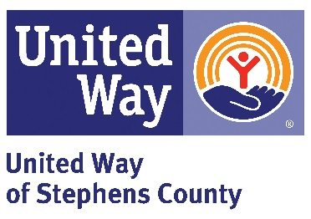

UNITED WAY DAY OF CARING
Friday, May 12, 2023
8:30 a.m.

GROUP/INDIVIDUAL__________________________________________________

GROUP COORDINATOR__________________________________

INDIVIDUAL/COORDINATOR’S CELL PHONE #________________________________

Volunteer Name: I can work the following shift(s)
8:30 – 12 12-4 Full Day T-Shirt Size
____________________________________________________________________________________________________________________________________________________________________________________________________________________________________________________________________________________________________________________________________________________________________________________________________________________________________________________________________________________________________________________________________________________________________________________________________________________________________________________________________________________
____________________________________________________________________________________________________________________________________
__________________________________________________________________

Volunteers need to be 14 years old and up, adult supervision required at all times.
(Lunch will be provided. Projects to be completed by 4p.m.)

Please return this list by Wednesday April 26th, 2023 to:

United Way of Stephens County, Inc.
P.O. Box 1632
Duncan, OK 73534-1632
PHONE: 580-255-3648

OR email your volunteer list to: Helen Stewart at hstewart@unitedwayofsc.org

